Q 10) Draw the E-K diagram of a semiconductor based on band theory of solids. Explain the Brillouin zones in a solid.

Ans. 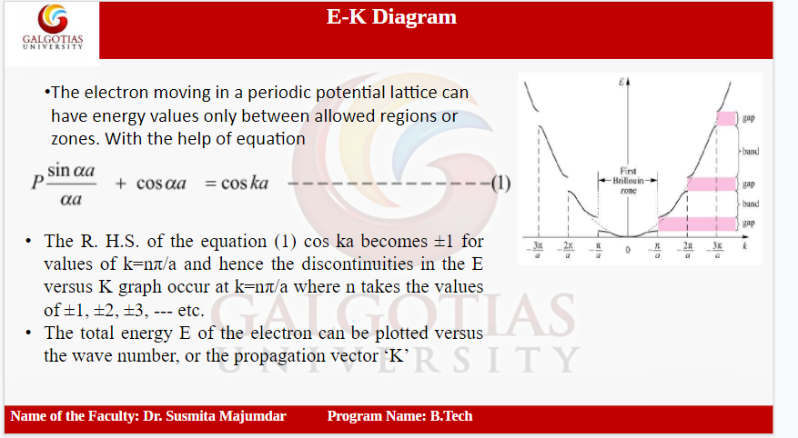

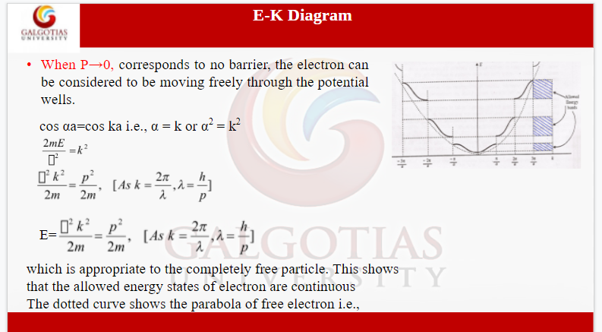

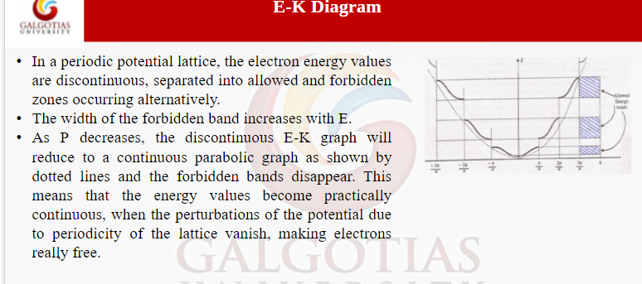

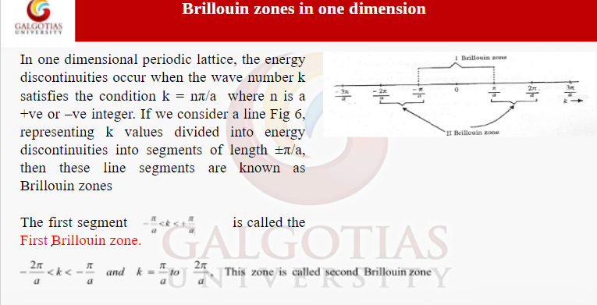

Q 11. What would be the band structure if the barrier strength is extremely high or negligible? Justify your answer with a suitable diagram.

Ans. 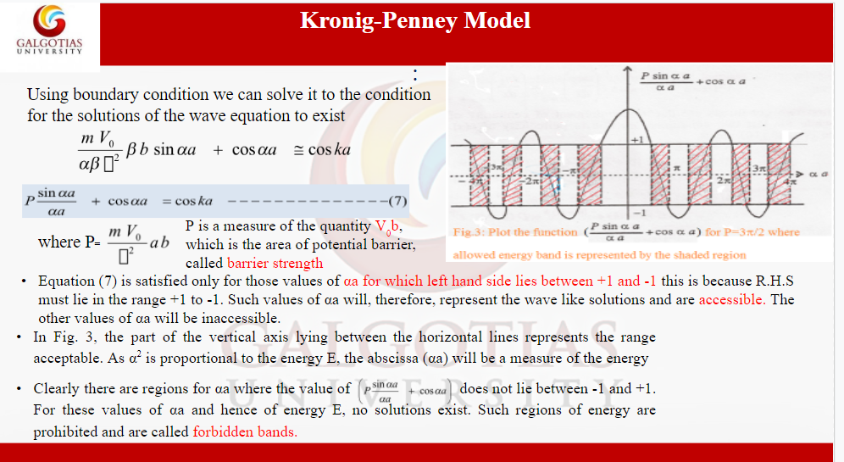

Q 12. Define the density of energy state in a solid. Find the expression for density of states.

Ans. 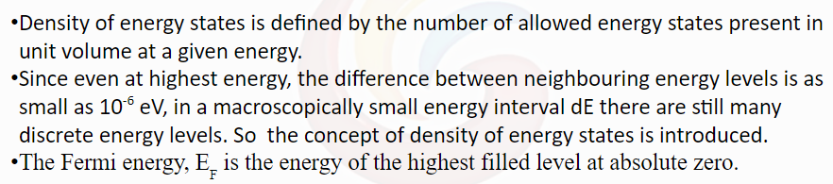

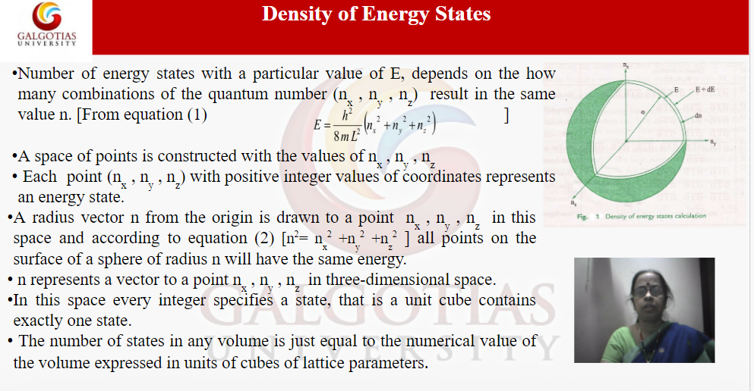

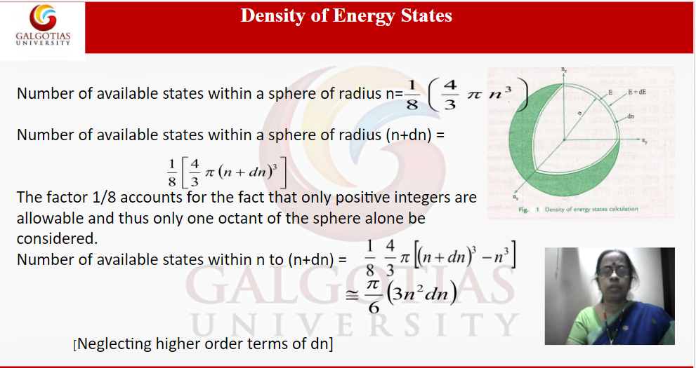

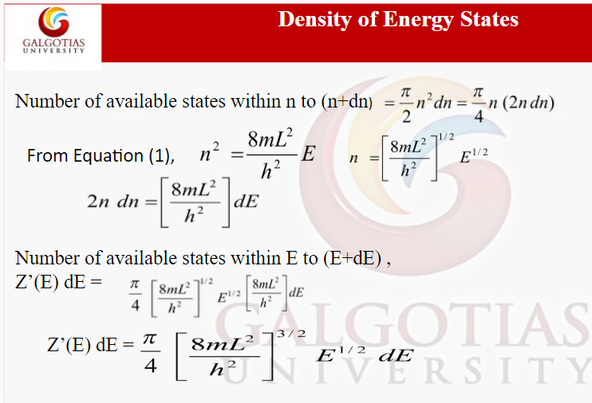

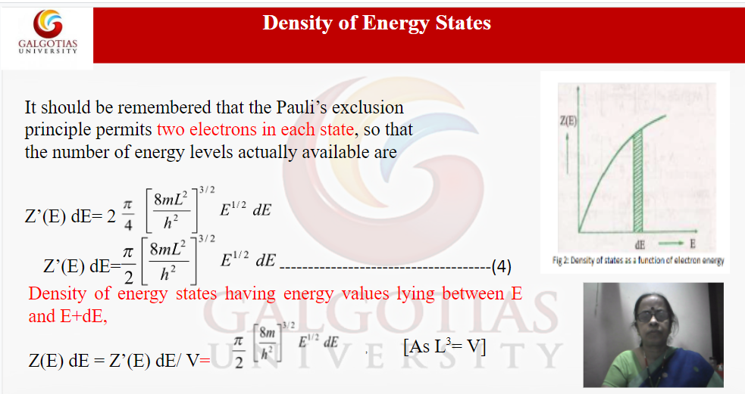

Q13. An electron is in motion along a line between x=0 and x= L with zero potential energy. At points for which x ≤ 0 and x ≥ L, the potential energy is infinite. The wave function for the particle in the nth state is given by ψn=A Sin (nπx/L). Find the expression for the normalized wave function.

Ans. Done in copy

Q14. An electron is in motion along a line between x=0 and x=L with zero potential energy. At points for which x ≤ 0 and x ≥ L, the potential energy is infinite. Solving Schrodinger’s equation, obtain energy Eigen values.

Ans. Answer not found

Q15. Explain the energy band in solids and classify the materials based on energy gap.

Ans. 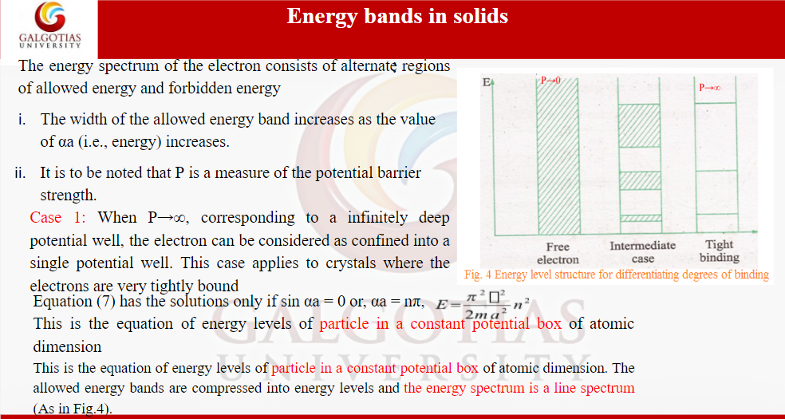

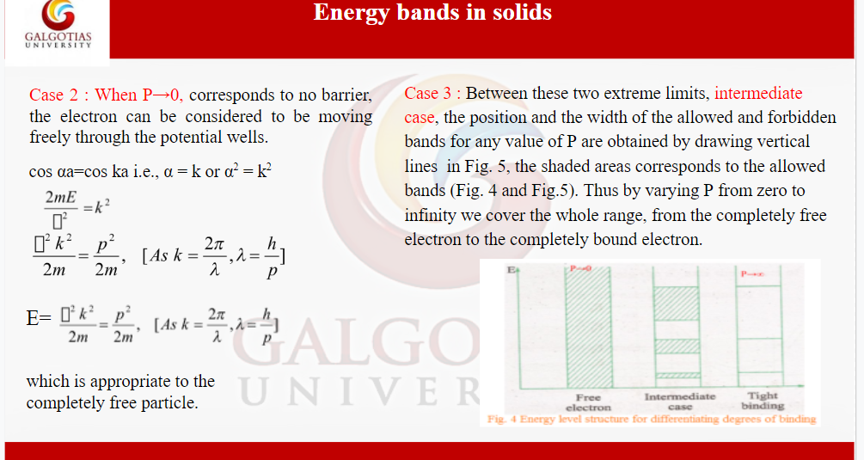

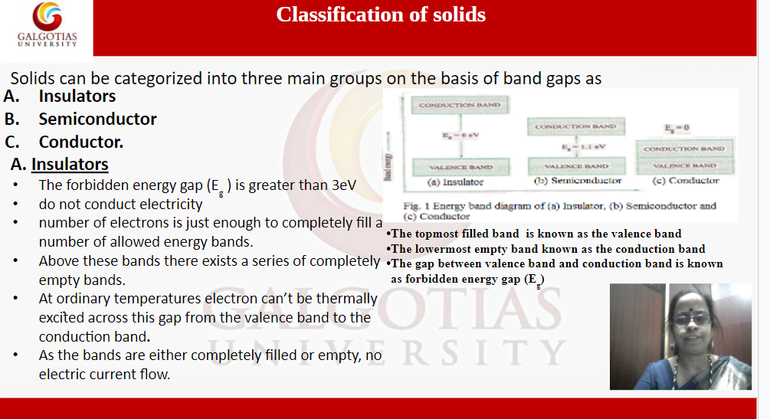

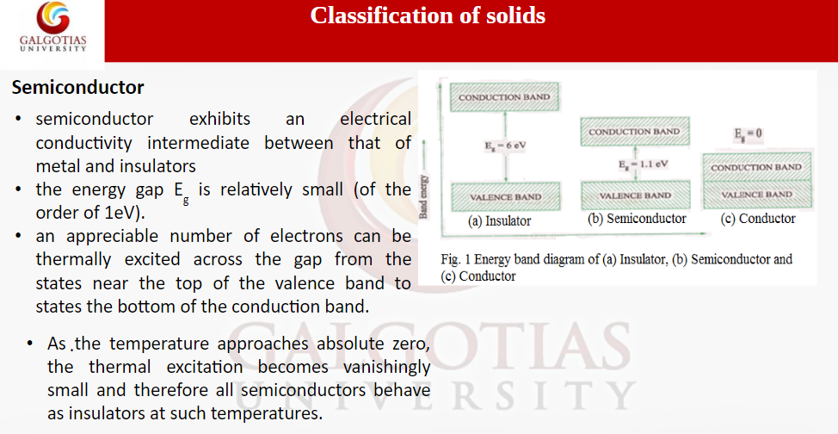

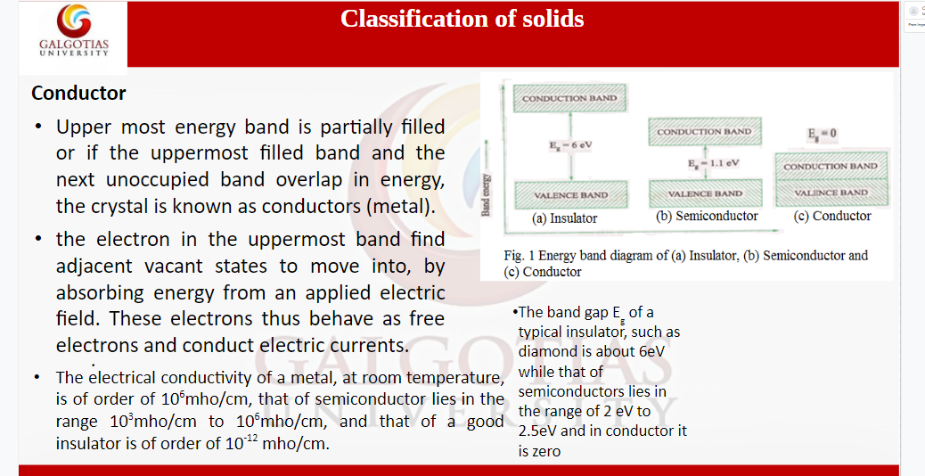

**Unit 2**

Q 15. Explain the extrinsic semiconductor. Using suitable diagram, discuss how the Fermi level changes with change of temperature in extrinsic semiconductors.

Ans. The impurity mixed intrinsic semi-conductors are called extrinsic semiconductor. The process of adding impurity is called doping. The purpose of adding impurities is either to increase the number of free electrons or holes in the semi-conductor crystal.

**IN n-TYPE SEMICONDUCTOR.**

* At 0K the fermi level E_{Fn} lies between the conduction band and the donor level.
* As temperature increases more and more electrons shift to the conduction band leaving behind equal number of holes in the valence band. These electron hole pairs are intrinsic carriers.
* With the increase in temperature the intrinsic carriers dominate the donors.
* To maintain the balance of the carrier density on both sides the fermi level EFnEFn gradually shifts downwards.
* Finally at high temperature when the donor density is almost negligible E_Fn is very close toEFiEFi.

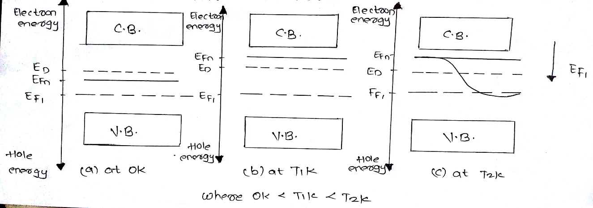

**IN p-TYPE SEMICONDUCTOR.**

* At 0K the fermi level EFpEFp in a p-type semiconductor lies between the acceptor level and the valence band.
* With the increase in temperature more and more holes are created in the valence band as equal number of electrons move to the conduction band.
* As temperature increases the intrinsic holes dominate the acceptor holes.
* Hence the number of intrinsic carriers in the conduction band and in the valence band become nearly equal at high temperature.
* The fermi level EFpEFp gradually shifts upwards to maintain the balance of carrier density above and below it.
* At high temperature when the acceptor density become insignificant as compared to the intrinsic density, EFpEFp is positioned very close to the intrinsic fermi level EFiEFi but little below it.

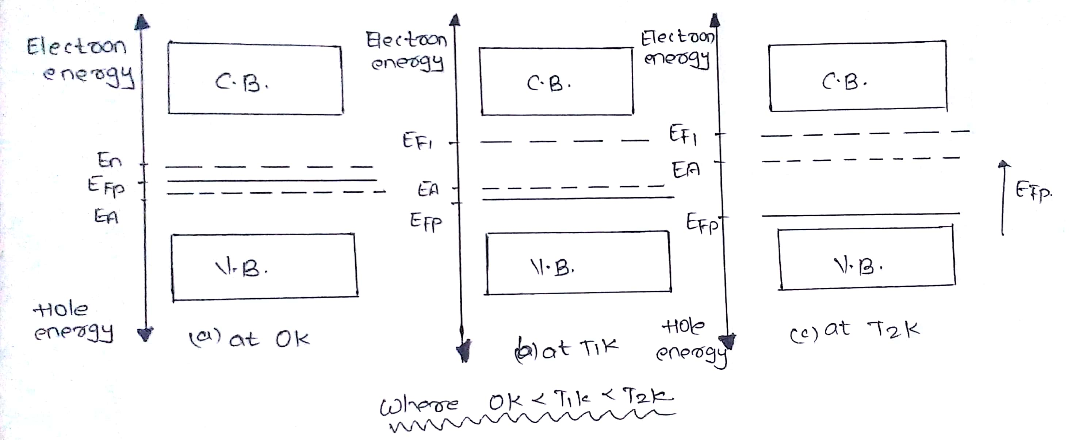

Q 14. Describe the P and N types semiconductors and indicate the Fermi level and energy level of impurity atoms in band diagram

Ans. Variation of Fermi level with impurity concentration

* At low impurity concentration the impurity atoms do not interact with each other. Hence, the extrinsic carriers have their own discrete energy levels.
* With the increase in impurity concentration the interaction of the impurity atoms start and the Fermi level varies in the following way. > IN n-TYPE SEMICONDUCTOR:-

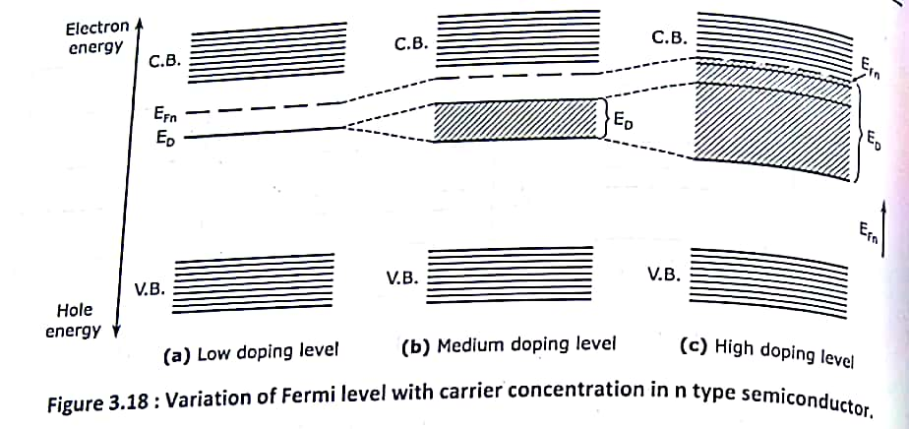

* As the impurity atoms interacts the donor electron are shared by the neighbouring atoms. This results in splitting of the donor level and formation of the donor band below the conduction band.
* With the increase in impurity concentration the width of the band increases. At one stage it overlaps with the conduction band

.

* As the donor band widens the forbidden gap decreases. In the process the Fermi level shifts upwards and finally enters the conduction band as shown:-

*IN p-TYPE SEMICONDUCTOR.*

* With the increase in the impurity concentration the impurity atoms interact. As a result the acceptor level splits into acceptor band which gradually widens with doping level increment.
* Finally the acceptor level enters the valence band. In this process the Fermi level shifts downwards and at high doping level it enters the valence band.
* With the widening of the acceptor band the forbidden gap decreases as seen:-

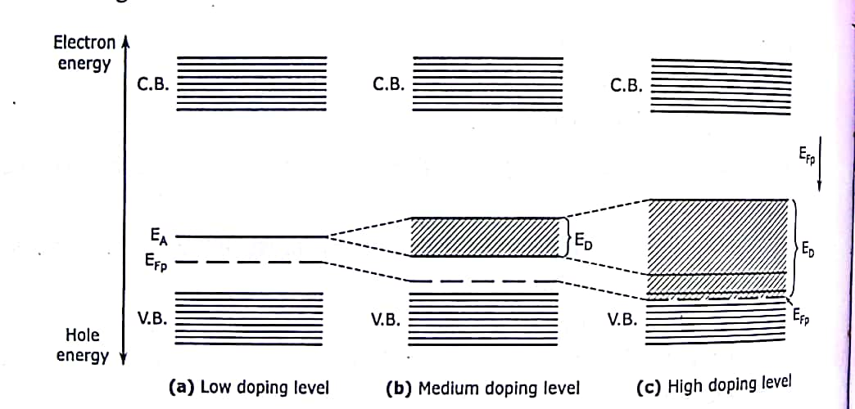

Q 13. Distinguish between the direct and indirect band gap semiconductors with one examples.

Ans.

| **Sr. No** | **Direct Band gap semiconductor** | **Indirect band gap semiconductor** |
| --- | --- | --- |
| 1 | A direct band-gap (DBG) semiconductor is one in which the maximum energy level of the valence band aligns with the minimum energy level of the conduction band with respect to momentum. | A indirect band-gap (DBG) semiconductor is one in which the maximum energy level of the valence band are misaligned with the minimum energy level of the conduction band with respect to momentum. |
| 2 | In a DBG semiconductor, a direct recombination takes place with the release of the energy equal to the energy difference between the recombining particles. | Due to a relative difference in the momentum, first, the momentum is conserved by release of energy and only after both the momenta align themselves, a recombination occurs accompanied with the release of energy. |
| 3 | The efficiency factor of a DBG semiconductor is much more than that of an IBG semiconductor. | The probability of a radiative recombination, is much less in comparison to that in case of DBG semiconductors |
| 4 | The most thoroughly investigated and studied DBG semiconductor material is Gallium Arsenide (GaAs). | The two well-known intrinsic semiconductors, Silicon and Germanium are both IBG semiconductors. |
| 5 | DBG semiconductors are always preferred over IBG for making optical sources. | The IBG semiconductors cannot be used to manufacture optical sources. |

Germanium is also an indirect bandgap material, whose valence band maximum occurs at k = 0 and whose conduction band minimum occurs along the [111] direction. GaAs is a direct bandgap semiconductor, but other compound   semiconductors such as GaP and AlAs, have indirect bandgaps.

Q12. Distinguish between intrinsic and extrinsic types of semiconductor with examples. Outline the nature of charge in an intrinsic semiconductor on addition of neutral trivalent impurity atoms.

Ans. INTRINSIC SEMICONDUCTORS:

1. It ispure semi-conducting material and no impurity atoms are added to it.

2.Examples: crystalline forms of pure silicon and germanium.

3. The number of free electrons in the conduction band and the no. of holes in valence band is exactly equal and very small indeed.

4.Its electrical conductivity is low.

5.Its electrical conductivity is a function of temperature alone.

EXTRINSIC SEMICONDUCTORS:

1. It is prepared by doping a small quantity of impurity atoms to the pure semi-conducting material.

2.Examples: silicon “Si” and germanium “Ge” crystals with impurity atoms of As, Sb, P etc. or In B, Aℓ etc.

3.The number of free electrons and holes is never equal. There is excess of electrons in n-type semi-conductors and excess of holes in p-type semi-conductors.

4.Its electrical conductivity is high.

5.Its electrical conductivity depends upon the temperature as well as on the quantity of impurity atoms doped the structure.

When a trivalent impurity is added an intrinsic semiconductor then **a P-type semiconductor** is formed

Q11. Distinguish between elemental and compound semiconductors with two examples

Ans. 1. Elemental Semiconductors are made from single element also known as mixed element. Compound Semiconductors as the name say are made from compound.

2. Elemental Semiconductors are made up from IV group and VI group elements. Compound Semiconductors are made from III and V group elements or II and VI group elements.

3. Elemental Semiconductors are called as indirect band gap semiconductor in which electron-hole recombination takes place through traps. Compound Semiconductors are called as direct band gap semiconductor in which electron-hole recombination takes place directly.

4. For Elemental semiconductors, Heat is produced in the recombination while for Compound semiconductors, Photons are emitted during recombination.

5. For Elemental semiconductors, Life time of charge carriers is more due to indirect recombination. For Compound semiconductors, Life time of charge carriers is less due to direct recombination.

6. In elemental, current amplification is more as compared to compound semiconductors.

7. Elemental Semiconductors are used for making diodes, transistor, etc. Compound Semiconductors are used for making LED, laser diodes, etc.

8. Example of Elemental semiconductors are Ge, Si. Example of Compound semiconductors are GaAs, GaP, CdS, MgO.

Q 10. Define the Fermi energy and Fermi distribution function. Plot the Fermi distribution function at two different temperatures.

Ans. The Fermi energy is a concept in quantum mechanics usually refers to the energy difference between the highest and lowest occupied single-particle states in a quantum system of non-interacting fermions at absolute zero temperature.

The value of the Fermi level at absolute zero temperature (−273.15 °C) is known as the **Fermi energy**. It is also the maximum kinetic energy an electron can attain at 0K. Fermi energy is constant for each solid.

The Fermi-Dirac distribution **applies to fermions, particles with half-integer spin which must obey the Pauli exclusion principle**. Each type of distribution function has a normalization term multiplying the exponential in the denominator which may be temperature dependent.

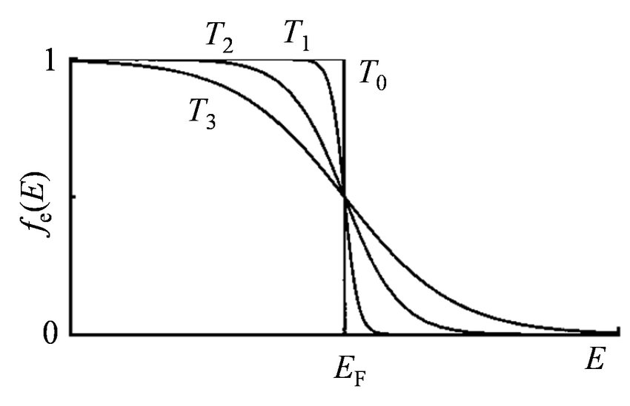

Q 9. Based on band theory of solids, distinguish between conductors, semiconductors, and insulators.

## Ans. Conductors

In a conductor there are no band gaps between the valence and conduction bands. In some metals the conduction and valence bands partially overlap. This means that electrons can move freely between the valence band and the conduction band.

The conduction band is only partially filled. This means there are spaces for electrons to move into. When electrons for the valence band move into the conduction band they are free to move. This allows conduction.

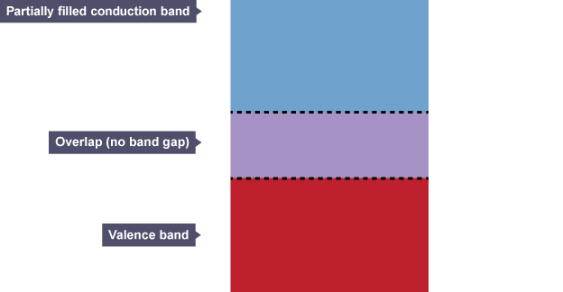

## Insulators

An insulator has a large gap between the valence band and the conduction band.

The valence band is full as no electrons can move up to the conduction band. As a result, the conduction band is empty.

Only the electrons in a conduction band can move easily, so because there aren't any electrons in an insulator's conduction band, the material can't conduct.

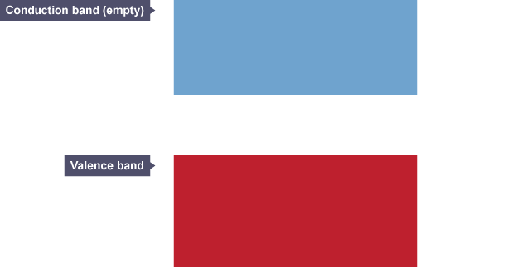

In a semiconductor, the gap between the valence band and conduction band is smaller. At room temperature there is sufficient energy available to move some electrons from the valence band into the conduction band. This allows some conduction to take place.

An increase in temperature increases the conductivity of a semiconductor because more electrons will have enough energy to move into the conduction band.

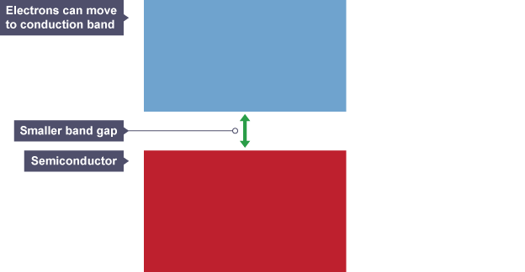

The difference between insulators and semiconductors is due to a small amount of impurity added to a semiconductor which affects the energy bands. This process is called doping.

Q8. Draw and interpret the graph for the Fermi Energy variation with temperature for P and N type semiconductors.

Ans. 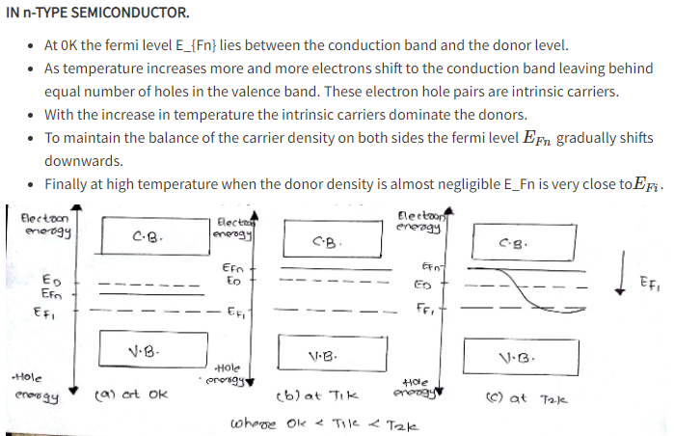

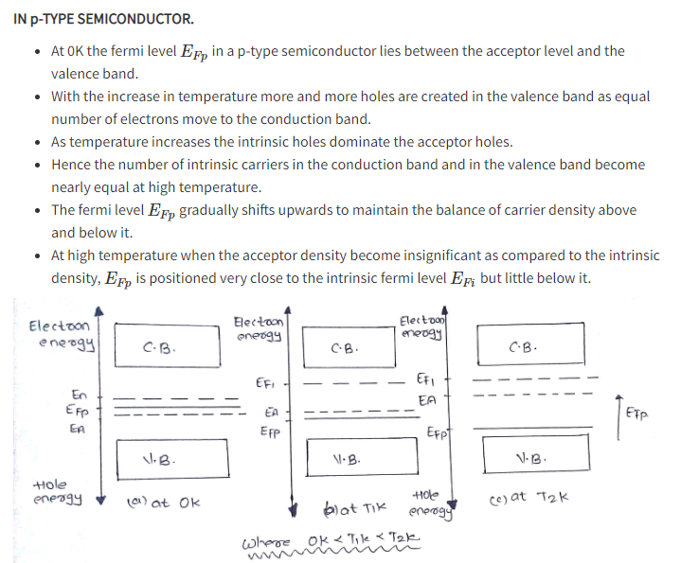

Q4. What is the wavelength corresponding to the bandgap of GaAs (1.42eV) approximately?

Ans. 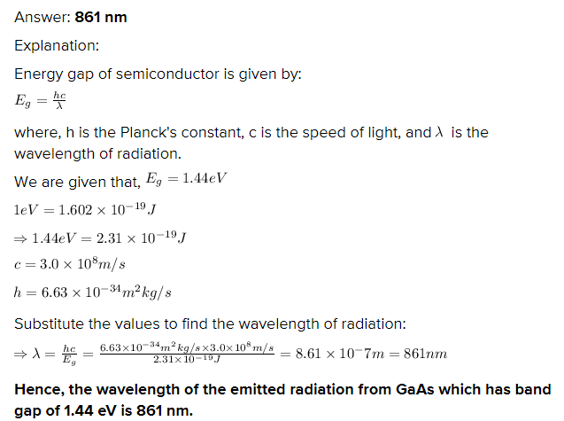

Q3. Define the relaxation time and Drift velocity of an electron in a semiconductor

Ans. The average velocity gained by particles such as electrons in any material due to the presence of an electric field  is termed as drift velocity.

Relaxation time is the time interval between two successive collisions of electrons inside a conducting material when a current is flowing through it.

Current flows in conductors due to the presence of free electrons. When the cuurent is flowing through it, the average speed of the electrons is the drift speed and the time interval between two successive collisions of these free electrons is the relaxation time.

Q2. Which types of charge carries are available in p-type of semiconductors? Justify your answer

Ans. When a trivalent impurity is added to a semiconductor then it is called p type semiconductor. Majority Charge carriers in p type semiconductor are holes. Minority charge carriers are electrons

Q1. Which types of charge carries are available in n-type of semiconductors? Justify your answer.

## Ans. In n-type semiconductor we add pentavalent impurities so there is excess of electrons inside the material. So, majority charge carriers are electrons.